# **Name: Abdurrahman Qureshi**

# **Roll No: 242466**

Practical No: 4

1) Program to demonstrate Linear Search

CODE

#include <stdio.h>

#include <stdlib.h>

#define size 20

int main()

{

    int a[size], i, n, x, pos = -1;

    printf("Enter size of array:- \n");

    scanf("%d", &n);

    printf("Enter elements \n");

    for (i = 0; i < n; i++)

    {

        scanf("%d", &a[i]);

    }

    printf("Elements are:- \n");

    for (i = 0; i < n; i++)

    {

        printf("%d\t", a[i]);

    }

    printf("\nEnter elements to search:- \n");

    scanf("%d", &x);

    for (i = 0; i < n; i++)

    {

        if (a[i] == x)

        {

            pos = i + 1;

            printf("%d is found at position %d", x, pos);

        }

    }

    {

        if (pos == -1)

        {

            printf("Elements not found \n");

        }

    }

}

OUTPUT

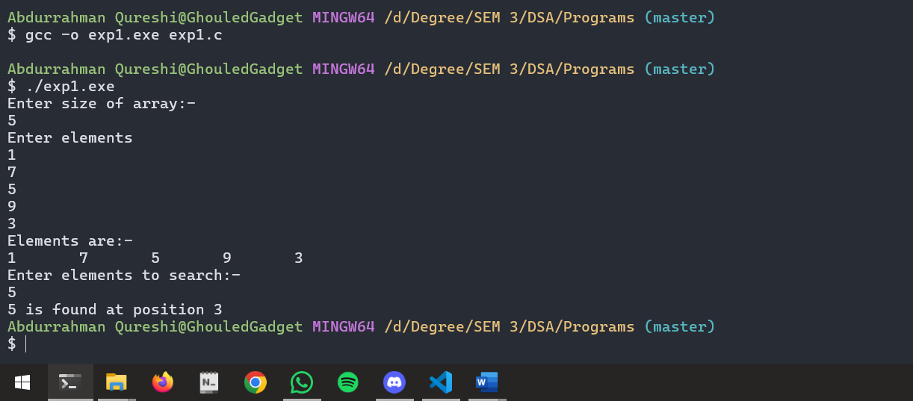

2) Program to demonstrate Binary Search

CODE

#include <stdio.h>

#include <stdlib.h>

#define size 20

int main()

{

    int a[size], i, n, x, pos = -1;

    printf("Enter size of array:- \n");

    scanf("%d", &n);

    printf("Enter elements \n");

    for (i = 0; i < n; i++)

    {

        scanf("%d", &a[i]);

    }

    printf("Elements are:- \n");

    for (i = 0; i < n; i++)

    {

        printf("%d\t", a[i]);

    }

    printf("\nEnter elements to search:- \n");

    scanf("%d", &x);

    for (i = 0; i < n; i++)

    {

        if (a[i] == x)

        {

            pos = i + 1;

            printf("%d is found at position %d", x, pos);

        }

    }

    {

        if (pos == -1)

        {

            printf("Elements not found \n");

        }

    }

}

OUTPUT

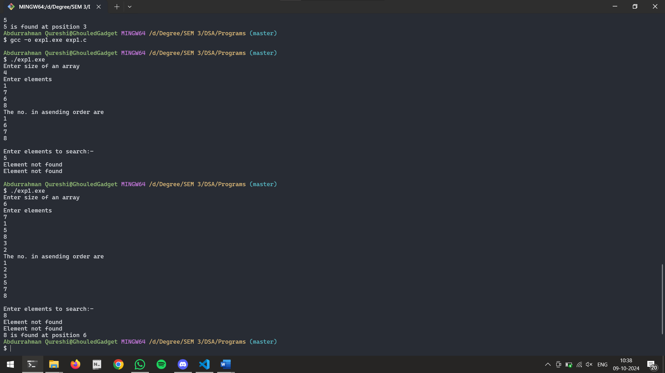

Tools used :

Software: Dev c++

Hardware: Lab Computers

References: Mam notes.

Conclusion

* Binary search helps to sort the elements.
* Binary Search is consistently faster than Linear Search.
* Linear search is less efficient when we consider the large data sets.
* Binary search is more efficient than the linear search in the case of large data sets.